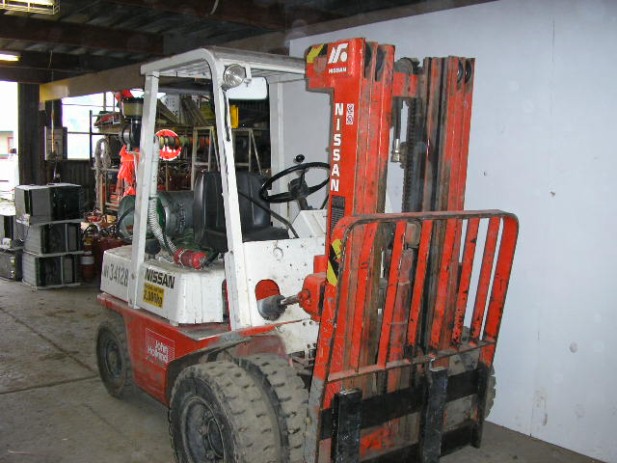 | Hazard Information Sheet
  Equipment: | Handling, Hoisting & Lifting
 | Equip Type: | Forklifts - Smooth Terrain
 | Generic Description or  Specific Make / Model: | Forklift
 | Type: | Diesel, Petrol, LPG
 | Other Details

Operator Requirements: | Operators must be trained and competent to use this equipment safely.
Purpose For Which This Equip Is Designed: | To elevate materials not exceeding the design lift capacity. For use on slab or smooth terrain only

Hazards & Risks:
Control Measures:
Crushing (Squashing):  Being trapped between the plant and materials, or fixed structures. | Avoid congested work areas. Keep personnel clear.
Driving into bystanders. | Clearly define work area. Keep personnel clear
Unexpected movement of plant. | Clearly define work area. Keep personnel clear
Lack of capacity for plant to be slowed, stopped or immobilised. | Operate on firm level surfaces.  Operator not to exceed gradeability of equip.
Plant tipping or rolling over or operator being ejected. | (i) Use only on stable, level surface capable of supporting its weight.  (ii) Wear seat belt (where fitted).  (iii) Always drive machine at a safe speed relative to the terrain and working environment especially when cornering.

Disclaimer: In fulfilment of its statutory obligations, (ARS) & John Holland has taken what it considers to be all reasonable precautions and exercised due diligence to ensure that it has provided all relevant information on the safe use of the plant. However, except as required by law and only to the extent so required, (ARS) & John Holland does not make any representation, warranty or undertaking, express or implied, as to, or accept any responsibility or liability for, the accuracy or completeness of, or any errors in or omissions from, this Hazard Information Sheet. Except as required by law and only to the extent so required, neither (ARS) & John Holland nor any of its respective directors, officers, agents, or employees shall in any way be liable directly or indirectly to any person or body for any loss or damages, costs or expenses whatever arising out of or in connection with the information contained in this Hazard Information Sheet. | Date: 19/06/06
Equipment: | Forklift  Petrol, Diesel, LPG

Hazards & Risks: | Control Measures:
Crushing (cont):  Parts of the plant collapsing. | (i) Do not overload.  (ii) Maintain and check lifting system.  (iii) Keep personnel clear when loading, unloading and during transportation
Being thrown off or under the equipment. | Do not allow other person(s) to ride on, travel on, drive or steer a forklift designed to carry one person only.
Entanglement:  Becoming entangled in moving parts | Keep personnel clear. Barricade off/designate work area.
Slipping, Tripping & Falling:  Slipping on hand holds, steps or floor | Keep hand holds, steps and floor clean and clear of oil, grease, mud, rubbish and tools.
Electrical:  Electrocution from overhead power lines, cabling or bus bars. | Maintain at least 6m clearance from overhead power lines.  Remember the golden rule i.e. “Look Up And Live” before raising forks.
High Temperature or Fire:  Refuelling: When refuelling, sparks, flames, hot engine can ignite fuel. | Operator is responsible to shut engine down prior to refuelling. Refuel in a well ventilated area. Ensure that there are no naked flames in the area. DO NOT SMOKE. Avoid spilling fuel and collect any fuel run off.
Coming into contact with hot parts. | Keep clear of engine and exhaust outlet.
Noise:  Exposure to noise. | Wear appropriate hearing protection.
Suffocation:  Suffocation due to lack of oxygen, or atmospheric contamination. | Use confined space procedures where applicable.
Exposure to exhaust fumes. | If working in poorly ventilated areas monitor exhaust fumes at regular intervals.

Disclaimer: In fulfilment of its statutory obligations, (ARS) & John Holland has taken what it considers to be all reasonable precautions and exercised due diligence to ensure that it has provided all relevant information on the safe use of the plant. However, except as required by law and only to the extent so required, (ARS) & John Holland does not make any representation, warranty or undertaking, express or implied, as to, or accept any responsibility or liability for, the accuracy or completeness of, or any errors in or omissions from, this Hazard Information Sheet. Except as required by law and only to the extent so required, neither (ARS) & John Holland nor any of its respective directors, officers, agents, or employees shall in any way be liable directly or indirectly to any person or body for any loss or damages, costs or expenses whatever arising out of or in connection with the information contained in this Hazard Information Sheet. | Date: 19/06/06

